Civics and Economics
South Stokes High School
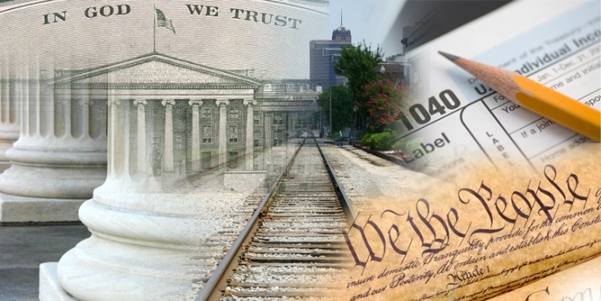
**Civics is the study of citizenship and government. In this course, we will discover what it takes to be a good citizen, how our government works and the importance of civic participation. We will also discuss the basic of economics and understand the role it plays in our society.
**By the end of the semester, students will be able to :
1. Identify and understand the root of the American political system and the values and principles of American democracy.
2. Know about and understand the purpose, meaning and effect of the United States Constitution.
3. Know what a government is and how it works at the federal, state and local level.
4. Identify and explain the roles of the legislative, judicial and executive branches of government.
5. Identity and understand what basic civil rights are, why they are important and how they are protected.
6. Know and explain how the legal systems provides a means to balance interest and resolve conflicts
7. Know what the concept of economics is and how it works on a personal and governmental level.
8. Analyze features of the economic system of the United States.
9. Develop, defend and evaluate positions on issues regarding the responsibilities of citizens in the US.

Below is a list of helpful websites and links that may help students be more successful in Civics:
1. North Carolina Department of Public Instruction- www.ncpublicschools.org
2. Center for Civic Education – www.civiced.org
3. The White House – www.whitehouse.gov
4. On-line Flashcards – www.studybulb.com
5. Practice EOC Questions – www.sampson.k12.nc.us
www.sog.unc.edu
www.northernvancehigh.org
**Students will also be given review workbooks towards the end of the semester to help them prepare for the end of course exam.
**Please contact me at with questions or concerns (shiela.patterson@stokes.k12.nc.us).
I look forward to a great semester!!

